* **Create a webservice to perform addition and subtraction operation and consume webservice in Java Class in Java SE Application & JSP Page in web application.**
* **Creating a Webservice**
* Choose File > New Project.
* Graphical user interface, text, application

  Description automatically generatedSelect Web Application from the Java Web & Click Next.
* Name the project WebService. Select a location for the project. Click Next.Graphical user interface, text, application, email

  Description automatically generated
* Graphical user interface, text, application, email

  Description automatically generatedSelect your server and Java EE version and click Finish.
* **Creating a Web Service from a Java Class**
* Graphical user interface, text, application, email

  Description automatically generatedRight-click the WebService node in project explorer window and choose New > Web Service.
* Name the web service as WSCALCULATOR and type com.wscalculator.calculator in Package.
* Leave create web service from scratch selected. If you are creating a Java EE 6 project on GlassFish,
* Select Implement Web Service as a Stateless Session Bean.
* Graphical user interface, text, application, email

  Description automatically generatedClick Finish. The projects window displays the structure of the new web service and the source code is shown in the editor area.
* **Adding an Operation to the Web Service**

The goal of this exercise is to add to the web service an operation that adds two numbers received from a client. The NetBeans IDE provides a dialog for adding an operation to a web service. You can open this dialog either in the web service visual designer or in the web service context menu.

**To add an operation to the web service**:

* Graphical user interface, text, application

  Description automatically generatedChange to the Design view in the editor.
* Click Add Operation in either the visual designer or the context menu. The Add Operation dialog opens.
* In the upper part of the Add Operation dialog box, type add in Name and type int in the Return Type drop-down list.
* In the lower part of the Add Operation dialog box, click Add and create a parameter of type int named parameter1.
* Click Add again and create a parameter of type int called parameter2. You now see the following:

* Click OK at the bottom of the Add Operation dialog box. You return to the editor.
* Graphical user interface, text, application

  Description automatically generatedThe visual designer now displays the following:
* Graphical user interface, text, application

  Description automatically generatedClick Source. And code the following.
* **Deploying and Testing the Web Service**

After you deploy a web service to a server, you can use the IDE to open the server's test client, if the server has a test client. The GlassFish servers provide test clients.

* To test successful deployment to a GlassFish server:
* Right-click the project and choose Deploy. The IDE starts the application server, builds the

application, and deploys the application to the server.

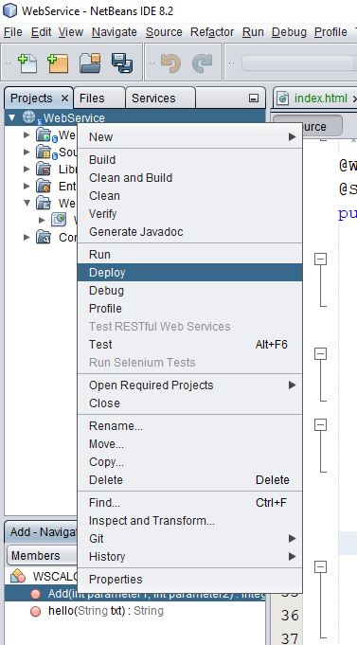

* In the IDE's Projects tab, expand the Web Services node of the WebService project.
* Right-click the WSCALCULATOR node, and choose Test Web Service

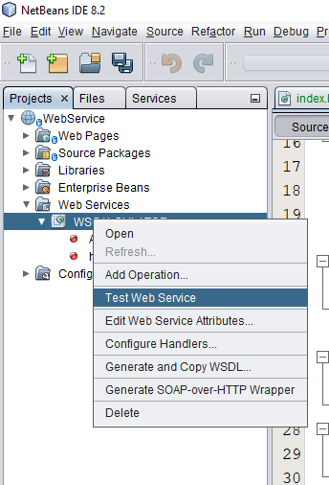

* Graphical user interface, text, application, email

  Description automatically generatedThe IDE opens the tester page in your browser if you deployed a web application to the GlassFish server.
* If you deployed to the GlassFish server, type two numbers in the tester page, as shown below:
* Graphical user interface, text, application, email

  Description automatically generatedThe sum of the two numbers is displayed:
* **Consuming the Web Service**
* Now that you have deployed the web service, you need to create a client to make use of the web service's Add method.
* **Client1: Java Class in Java SE Application**
* Choose File > New Project. Select Java Application from the Java category.
* Name the project WSClient.
* Graphical user interface, text, application, email

  Description automatically generatedGraphical user interface, text, application

  Description automatically generatedLeave Create Main Class selected and accept all other default settings. Click Finish.
* Right-click the WSClient node and choose New > Web Service Client. The New Web Service Client wizard opens.

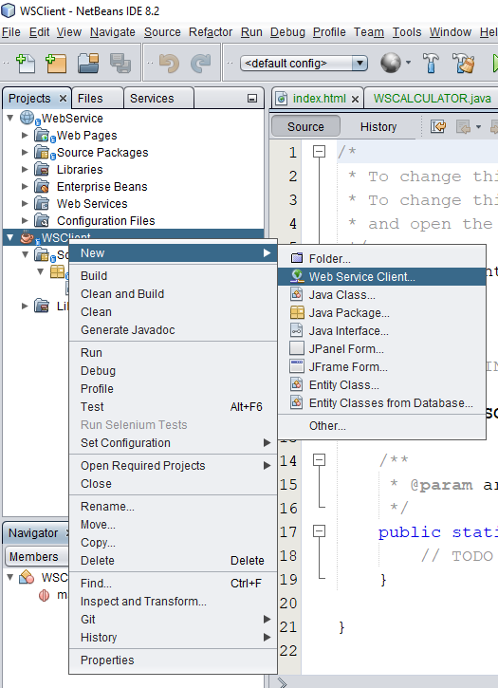

* Select Project as the WSDL source. Click Browse. Browse to the WSCALCULATOR web service in the WebService project. When you have selected the web service, click OK.

* Graphical user interface, text, application, email

  Description automatically generatedDo not select a package name. Leave this field empty.
* Leave the other settings at default and click Finish. The Projects window displays the new web service client, with a node for the add method that you created:
* Double-click your main class so that it opens in the Source Editor. Drag the add node below the main() method (or ) you can right-click in the editor and then choose Insert Code > Call Web Service Operation.

* In the main() method body, replace the TODO comment with code that initializes values for i and j, calls add(), and prints the result.

* Right-click the project node and choose Run.
* The Output window now shows the sum:

* **Client2: JSP page in web application.**
* Choose File > New Project.
* Graphical user interface, text, application, email

  Description automatically generatedGraphical user interface, text, application

  Description automatically generatedSelect Web Application from the Java Web category. Name the project WSJSPCLIENT.
* Click Next and then click Finish.
* Expand the Web Pages node under the project node and delete index.html.

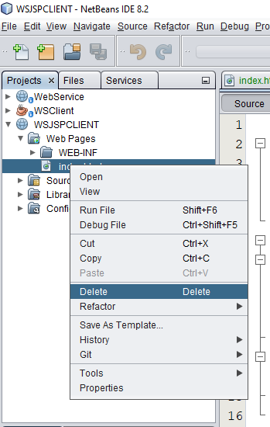

* Right-click the Web Pages node and choose New > JSP in the popup menu.

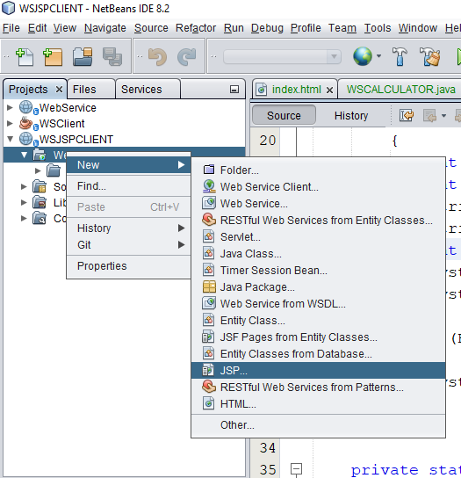

* If JSP is not available in the popup menu, choose New > Other and select JSP in the Web category of the
* New File wizard.
* Type index for the name of the JSP file in the New File wizard. Click Finish.
* Right-click the WSJSPCLIENT node and choose New > Web Service Client.

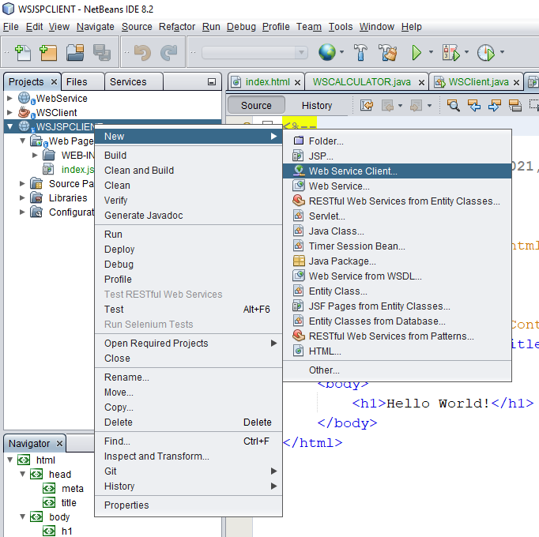

* Select Project as the WSDL source.
* Click Browse. Browse to the WSCALCULATOR web service in the WebService project.
* Graphical user interface, application

  Description automatically generatedWhen you have selected the web service, click OK.
* Do not select a package name. Leave this field empty.
* Graphical user interface, text, application, email

  Description automatically generatedLeave the other settings at default and click Finish.
* The Projects window displays the new web service client, as shown below:

* In the Web Service References node, expand the node that represents the web service.
* The add operation, which you will invoke from the client, is now exposed.
* Drag the add operation to the client’s index.jsp page and drop it below the H1 tags.

* Right-click the project node and choose Run.
* Graphical user interface, text, application, Word

  Description automatically generatedThe server starts if it wasn’t running already. The application is built and deployed, and the browser opens, displaying the calculation result: